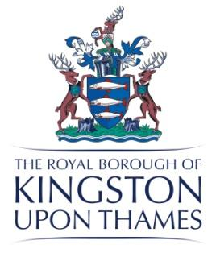
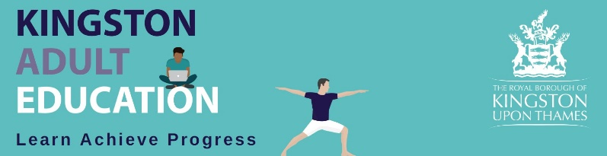

K A E Governors’ Advisory Board
A meeting was held on Wednesday 21st September 2022
at 6.30pm
in Guildhall

Present: | Apologies:
Hilda Clarke - HC (Chair)  Sam Burgess - SB  Lesley Searle - LS  Rebbecca Roberts - RR  Barry Avery- BA  Roger Weatherhead - RW  Sarah Jordan - Clerk to Governors - SJ | Dennis Clarke - DC
- Apologies
Apologies were received from Dennis Clarke SJ
- Minutes of last meeting Approved
HC noted that this was Dennis Clarke’s second year on the Advisory Board. She also mentioned that Councillor Bailey had lost her seat so we don’t currently have a councillor on the Board.

- Matters Arising and Declarations of Interest

No declarations of interest.

4 Report by the Principal
Review 2021-22
The Service operated from over 12 different sites. This comes with logistical challenges such as IT support with 1 technician.
Locations that have been particularly successful are the Corner House for LLD Drama or the large light room in Surbiton annex which has proved popular.

Overall there have been 244 more enrolments compared to 20/21 and 56 more courses.
Online or hybrid accounts for 55% of courses in 21/22 it was 75% in 20/21.

Achievements 2021-22
An example of the achievements for some of the courses are below;
GCSE English 94.4% success with 88% of those who took the exam achieving a high pass.
GCSE Maths 71% success with 100% of those who took the exam achieving a high pass.
ESOL 91.1% success
Book-keeping level 1 87.5% success.

Finances 2021-22
2021/22 FY had a budget surplus of £216k this was achieved and slightly exceeded.

RR asked if KAE would be keeping its surplus as recommended by the most recent independent report by Social Finance.

SB explained that the financial situation was very difficult for the council at the moment. She believes that KAE has a future and that there are clear plans for its development. It is important to continue to be an income generator. All the different reviews of KAE have been sent to Scott Furlong the Corporate Head of Culture. A large amount of time and money has been spent on different reviews over recent years.

HC reiterated what a positive review the 2022 Social Finance paper was.

Marketing
The marketing plan for 2022 includes a new e-prospectus, a Comms marketing campaign with various different strands, billboards, community noticeboards, RBK matters, Promotional events, social media and leaflets.

Enrolments
Year number of enrolments
2020 513
2021 522
2022 621

In order to help increase the number of enrolments the service is putting on more ESOL courses to meet the increasing demand.

HC asked if this pattern was common to other AE providers

SB explained that is was but that KAE problems were exacerbated by the premises issues.

KPI’s 2022/23
Achievement 93%
Retention 95%
Attendance 85%
Progression 35%
Learner Satisfaction 95%
Learner Mental Wellbeing 75%
Staff Mental Wellbeing 90%

SB discussed how difficult it is to get learner progression data once learners have left KAE.

Themed Weeks and Events
The various themed weeks were outlined.
RR asked if we used our week in The Rose theatre to publicise our courses.
SB Agreed that we didn’t specifically do this and that taster sessions for some subjects might be a good idea.

Projects and New Courses

The new MIS system is being used for online registers. Tests have highlighted some issues that are being resolved with a plan to be operating online enrolments by January 2023.
£30k has been invested putting PC’s into libraries.
A number of new courses have started such as;
British Nationals Overseas a programme for Hong Kongers,
ESOL courses for Ukrainian and Afghan refugees,
Understanding Autism and SEN in schools and
Environmental sustainability

Areas for Improvement 21/22 – staff
These are detailed in SB’s report.
An example of some areas highlighted are;
The need to be paid for prep time. Staff are now paid for preparing and developing new courses.
An alternative to the online English assessment. A revised assessment has been adopted.
A smoother way of communicating to staff. A KAE update has been introduced for all staff.

SB mentioned it would be good to have pictures of the Governors on the KAE update

SJ Action – to look for Governor Photos.

SB told the Governors that the KAE Wellbeing Tutor won an RBK community hero award.

Areas for improvement 22/23
These are detailed in SB’s report.
2 areas for improvement that were mentioned a number of times were the need for a central base and the amount of course cancellations. In order to reduce the number of courses cancelled they are being more heavily promoted and promoted earlier to try and ensure they are full. The premises issue is being worked on with the Guildhall staff area available from November.

Strengths 22/23
These are detailed in SB’s report.
HC noted that all the strengths detailed by staff have been achieved in very difficult circumstances with no fixed premises and no tutor area.
SB agreed that the staff at KAE were amazing and hardworking and needed central premises. The plan is for staff to have a dedicated space in the Guildhall by November and 2 classrooms by January.
HC agreed that this news along with the high demand for ESOL was very positive.

Chairman’s Report
HC noted that it was frustrating that the findings of the recent Social Finance review had not been acted upon. The current financial issues are counterproductive to building KAE.
The staff conference was impressive. It is clear that the lack of a permanent base and the issues with the new MIS system need to be resolved. These issues are being addressed.

HC has a meeting with Scott Furlong the Corporate Head of Culture tomorrow and will be reinforcing the issues facing KAE and asking for his support.

Members of the Advisory Board were voted on in January 2020 for 4 years. Due to Covid it seemed sensible to increase this to 5 years. All Governors were happy with this proposal.

The Chairperson is voted on for 3 years and all Governors were happy due to Covid to increase this to 4 years.

The student Governor is voted on for 2 years and is now in his second year.

HC is going to draft a profile of a KAE Governor so we can begin to recruit some additional Governors.

SB told the meeting that Ofsted were in Sutton at the moment and that new curriculum managers were currently having Ofsted training.

RR and BA volunteered to liaise with Ofsted on behalf of the Governors.

SB arranged an Ofsted training meeting for Wednesday 28th September.

AOB

Safeguarding
BA asked if safeguarding reporting had reduced as we have no fixed base.
LS agreed that it had an impact and that safeguarding cases were lower.
SB mentioned that the fact we no longer deliver courses for 16-18 year olds or Apprentices had an impact on numbers.
LS Action – to review the safeguarding figures with HC

The meeting closed at 8.00pm

