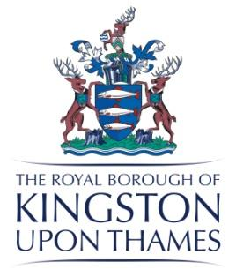
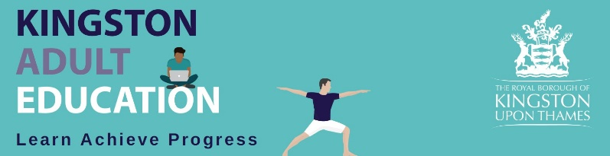

K A E Governors’ Advisory Board
A meeting was held on Wednesday 25th May 2022
at 6.30pm
in Guildhall

Present: | Apologies:
Hilda Clarke - HC (Chair)  Sam Burgess - SB  Lesley Searle - LS  Rebbecca Roberts - RR  Barry Avery- BA  Dennis Clarke - DC  Nicky Morris - NM  Sarah Jordan - Clerk to Governors - SJ | Michael Hill – MH (Vice)  Roger Weatherhead - RW
- Welcome to our new Student Governor Dennis Clarke HC
HC welcomed Dennis Clarke our new student governor to the Board. He is a long standing student of KAE and we look forward to working with him. His appointment is for a 2 year period.
HC thanked Michael Hill for his service to KAE and informed the Governors that MH was stepping down from the Advisory Board.
- Minutes of last meeting Approved
- Matters Arising and Declarations of Interest
Confirmation that Councillor Bailey did not regain her seat and so is no longer on the Board. We will await a new Councillor appointment.

No declarations of interest.
4 Report by the Principal

SB reviewed her report.

Enrolments
The Service is achieving consistently higher levels of enrolments than last year but they are still not as high as pre Covid figures. SSL (specialist skills and leisure) is 66% down on enrolments pre Covid.
HC- why do we think this is?
SB – People are tentative and our marketing needs to be stronger.
DC – Do we have sufficient classroom space to deal with higher numbers?
SB – No the quality of the spaces is not of a high enough standard.
LS – There are lots of advantages delivering our courses in the community but not all the sites are good for public transport.
RR – asked why there was such a gap between applications and enrolments.
SB – explained that after the application learners find the course isn’t right for them or the qualification isn’t what they expected so it doesn’t translate to an enrolment.
LS – discussed how a number of learners apply to study both maths and English GCSE but due to the demands of studying 2 GCSE’s in 1 year we only let them take 1.

Service Update

KAE is part of Culture with Libraries, Arts, Music Service and Museums. KAE were removed from the services review so an independent review could take place.

The other areas in Culture are in phase 2 of consultation. Back office support has been moved to 1 support hub. 3 leaders have been appointed with everyone due to be in place by September.

A very comprehensive review of KAE was undertaken by Social Finance. This review started in November 2021 and finished March 2022.

Executive Summary

Overview
KAE is a high quality provision.
It is a breakeven service.
The majority of learners are female (80%) with an under representation of Asian learners compared to the Kingston demographic.
There are 3 key reasons for accessing the service;
Finding employment, improving health and wellbeing and finding a purpose.
The Hybrid model is working well. There is an opportunity to expand the provision of some courses to all year round teaching.
The model is financially sustainable.
KAE is the “go to provide” for ESOL and employability. There are opportunities to expand the provision of digital and green skills courses.
There is concern about having no base both for running courses and staff retention.
KAE could strengthen its partnerships with the council, community organisations and other education providers.

Recommendations
KAE should clearly define its key priorities
KAE should lead a borough wide skills strategy aligned with other local providers.
The course offering should be expanded to include digital and green skills.
There should in the short term be a base for tutors and staff to work from. In the medium term a multipurpose base should be available to include teaching provision.
KAE should improve its outreach into the community and underrepresented groups.
KAE should expand its marketing of paid courses to increase occupancy.
The council should consider KAE retaining its surplus to invest in future projects.

SB – I am happy with the report and its findings. The Council now needs to agree which of the recommendations they take forward.

There is going to be an audit and asset review of all Kingston Council properties. This will be very helpful to KAE when reviewing all possibilities for a permanent base.

DC- Do we pay for our premises?
SB – Yes but not at commercial rates
LS – We must be paying much less for premises.
SB –yes but if we had more room we could generate more income.

The strategy document has been completed up to 2026 and will be sent out to learners and Governors.

MIS update
We are currently in the middle of updating our MIS service.
The system implementation has not gone totally to plan. Things will be much easier when we move to the cloud which the system is designed for. It is expected that learners will be able to pay for courses online from July.

Recruitment
Elisabeth Jarret is returning to KAE to be the SSL manager. This is an excellent appointment of a manager who knows the service very well.

Programme planning is going well. Green skills courses are being introduced. Mental wellbeing courses are being increased. There is a new job search programme with new IAG officers helping individual learners with employability. There are a number of courses specifically for Ukrainian and Afghan refugees.

Bid
A bid for £300k has been submitted as part of the Mayors Academy for health and social care.

Learner Survey

There were 299 responses which is approximately 20% of learners.

-Information and guidance received was graded as excellent or good by 80% of responders. This is down 7% on last year.
-Staff were rated as extremely or very friendly by 88% of respondents. This is 6% down on last year.
- 96% of learners stated their course had enabled them to improve in 1 or more areas. This is the same as last year.
- Learners liked the teaching, improving skills and making friends most about their courses.
- Improvements learners would like to see are more practice speaking, reading and writing. Having more teaching hours for courses and more courses in general.

The belief is that not having a centre and so having less face to face contact with learners has negatively impacted on some of these results.

Action SJ – to send out the slides of SB’s presentation, the Learner survey and the independent review
DC –asked if we could expect a major uplift in enrolments in September.
SB – expects an uplift but also explained that the cost of living rises will impact on enrolments.

Chairman’s Report

HC - expressed how fundamental for KAE it was to get people back joining our courses. This will be greatly helped if we get a permanent base.

HC - told the Governors that she has been to the House of Lords with the maths GCSE student Susan Gunakekera who received an award for being best student of the year and her tutor Sarah Jordan.

AOB

SB – Congratulated NM in her new job and expressed how much she will be missed at KAE. She is leaving KAE in August.

It was agreed that future meetings would be in person as far as possible with Governors having the option to join online if they couldn’t make it.

The next meeting is scheduled for September 21st 6.30pm in the Guildhall

The meeting closed at 8.10pm

