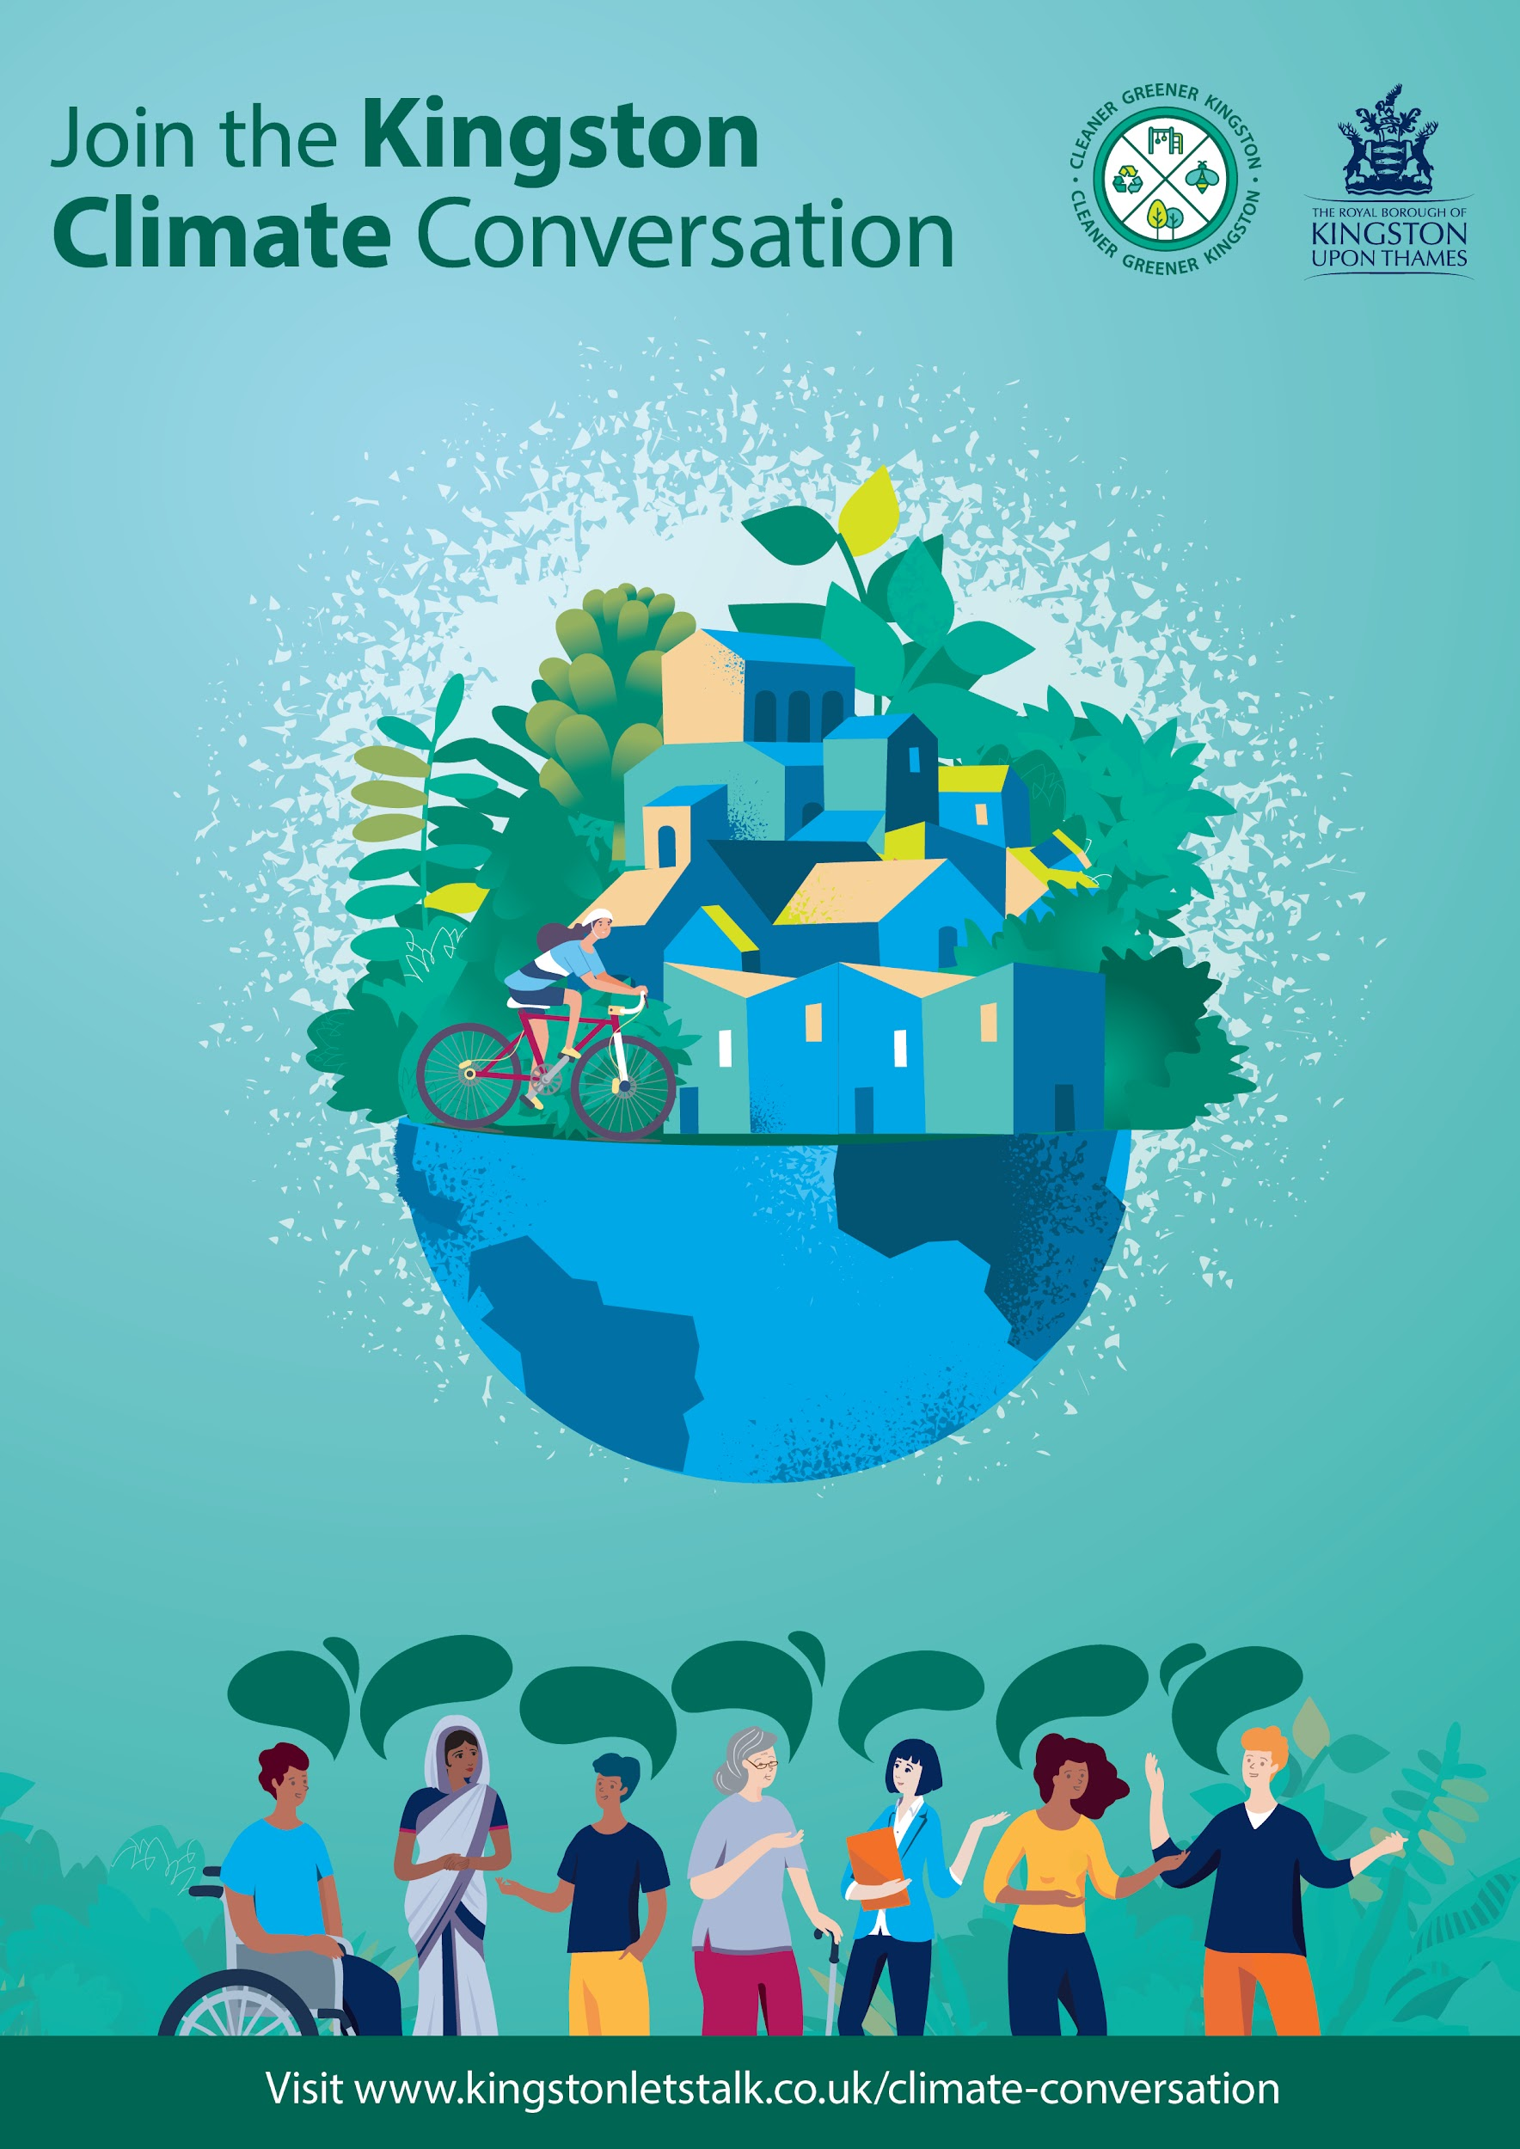

Climate Conversation Focus Group - discussion guide

Kingston Council would like to hear your views about the draft Climate Emergency Draft Action Plan.
We’re inviting community groups and other organisations to carry out short focus groups by the 30th November to inform how we develop and deliver our action plan.

A copy of the action plan can be found at Kingston’s Climate Conversation hub: kingstonletstalk.co.uk/climate-conversation.

A Climate Conversation can be carried out by any group of people online. There are seven themes to be discussed, and you can find out more information on each of these by visiting the hub page above.
If your group would like to respond to multiple themes, please complete a discussion guide response for each one, so that we can accurately analyse the results.
If you would like to respond to this consultation on an individual basis rather than with a group, please visit the council’s Climate Conversation hub: kingstonletstalk.co.uk/climate-conversation.
If you have any questions about the information provided, or need it in a more accessible format, please get in touch on the below email address with your email address and / or phone number and a preferred method of contact.
Once you’ve completed this discussion response, please return by the 30th November to strategy@kingston.gov.uk or by post to Communications Team, Guildhall 2, High Street, Kingston, KT1 1EU

General Questions
If you have already answered questions 1 - 5 as part of a previous theme response, please tick this box and make sure to send the responses in together.

- Please describe who participated in this discussion and how many people were involved. Do you belong to or represent any community groups?

- Do you think the proposed plan covers all aspects of a good response to the climate emergency? If not, what areas are missing, or should be strengthened?

- Do you think that tackling the climate emergency should be a priority for the council?
  - It should be the top priority for Kingston Council
  - It should be a top 5 priority for Kingston Council
  - It should not be a priority for Kingston Council
  - Other

- What do you think the council should do to make the climate emergency more visible to communities?

- Tackling the climate emergency will bring other benefits to Kingston. We are interested to find out which of these benefits are most important to you. Please rate each benefit not important, quite important or very important.

Co-benefits | Not important | Quite important | Very important
Quieter, safer streets
Warmer, quieter homes
Green jobs
Green spaces that are alive with biodiversity
Locally generated, secure energy
Healthier, more active people
A reduction in poverty and inequality
More local consumption, with thriving local businesses and high streets
Better air quality

Theme Questions
Which theme are you discussing as part of this Climate Conversation?
- Theme 1: Efficient buildings
- Theme 2: Efficient Homes
- Theme 3: How we travel
- Theme 4: Waste Reduction
- Theme 5: Green Economy
- Theme 6: Sustainable Council
- Theme 7: Natural Environment

- After reviewing the actions for this theme, do you have any comments about the actions included, or the theme itself?

- Are there any areas within this theme that you feel the approach should focus on more or less?
More focus on | Less focus on

- What are the barriers to the community taking more action in this theme?

- What further steps could the community take to support this theme?

Thank you for taking the time to join this Climate Conversation and help Kingston to be a cleaner, greener borough.

